**How to request Swipe Access to ECE Design Labs**

**Purpose:** This process is used to requesting swipe access to ECE Design Labs located in 234 Whittemore Hall and 363 Durham Hall. 234 Whittemore is used for ECE hardware development and 234 Whittemore is used for Robotics and Computer Engineering.

**Application:** Students enrolled in ECE 4805/4806 and members of the following organizations VT CRO, Inspirefly, and AMP. Special authorization can be requested via the Lab Manager.

**Process:** Swipe access to the afore mentioned labs can be obtained by completing steps 1-5 below:

**Da following links for trainings don’t work. Go to (**[**https://ehss.vt.edu/train.php**](https://ehss.vt.edu/train.php)**) to select which trainings to sign up for.**

**

**HOW TO FIND FIRE EXTINGUISHERS**

**HOW TO FIND POWER TOOL AND PPE AWARENESS**

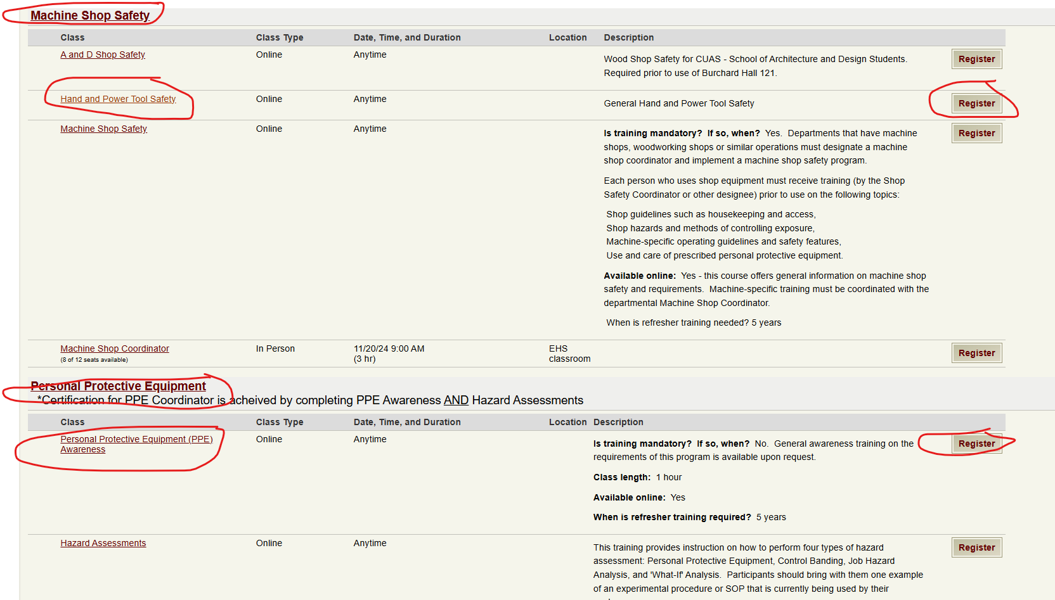

1. **Complete the following VT Environment Health and Safety (EHS) training:**

* Hand & Power Tool Safety
  + General Training/Hand & Power Tool Safety [https://www.ehss.vt.edu/detail_pages/training_details.php?training_id=3021]
* Personal Protection Equipment (PPE) Awareness
  + Personal Protection Equipment / PPE Awareness [https://www.ehss.vt.edu/detail_pages/training_details.php?training_id=337]
* Portable Fire Extinguisher Training
  + Fire and Life Safety/ Portable Fire Extinguisher Training [https://www.ehss.vt.edu/detail_pages/training_details.php?training_id=331]

**This is no longer a required step and does not need to be completed:**

1. **Lithium Ion Battery Safety**

* Watch the following videos:
  + Lithium Ion Battery Explosion [https://www.youtube.com/watch?v=nFgXFIa8luY]
  + Dangerous Lipo Battery Mistakes – Fire and explosion causes [https://www.youtube.com/watch?v=JrlLe6PRhyo]
* Read Seven Things You Need To Know About Lithium Ion Battery Safety [https://newsroom.unsw.edu.au/news/science-tech/seven-things-you-need-know-about-lithium-ion-battery-safety]
* STORAGE: Place bad Lithium Ion Batteries in grey ammo cans marked “Lithium Ion Battery Disposal”. Ensure the battery has been discharged prior to placing in the ammo boxes. Do Not short the battery across terminals.

1. **Read the *Lab Policy*, as outlined on the website www.amp-lab.com**/**docs/swipe-access**

**Email the lab waiver to** [**TOBY88@vt.edu**](mailto:TOBY88@vt.edu)

1. **Read and Sign the *Lab Waiver*, as outlined on the website www.amp-lab.com**/**docs/swipe-access**
2. **Submit Official Lab Access Request via Email**

Submit official Request via Email to the appropriate approving official as follows:

* **ECE 4805/4806** send the following information to MDE Instructor, Prof. Daniel Connors, dpconnors@vt.edu.
* **All other request** should be submitted via email to Lab Manager, Prof. Toby Meadows, [toby88@vt.edu](mailto:toby88@vt.edu).

**Your Email should include the following:**

* + 1. VT EHS summary of training completed
    2. Signed lab waiver
    3. Identify the lab you are requesting access for, e.g., 234 Whittemore and/or 363 Durham
    4. Organization i.e., AMP, Inspirefly, VTCRO, ECE 4805/4806, etc.
    5. For AMP member applicants Only - include your project link

**Example email for Swipe Access Request**:

As a member of [Organization (d)], I am respectfully requesting access to [Lab Identification (c)]. See attached documents for proof of VT EHS training and signed Lab Waiver.